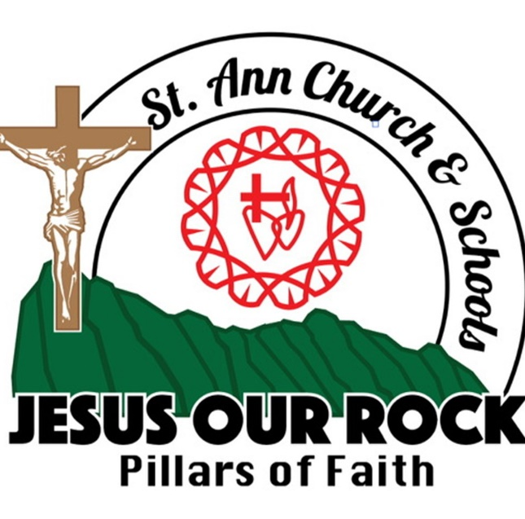

CONTACT US AT 247-3092

1

Parish Rectory……………………………….…………Ext. 111

Religious Education Office……………………….….Ext. 104

Director of Religious Education……………..……..Ext. 103

School………………………………………..…………..Ext. 102

Early Learning Center……………………….…….…..Ext. 130

Business Office………………………………….……..Ext. 123

Visit our Website at http://www.saintannhawaii.org

Email: stanns@saintannhawaii.org

Religious Education Office Hours:

Monday – Thursday 7:30am-4:00pm

Sunday 8:00am-2:00pm


“To the Sacred Hearts of Jesus & Mary, Honor and Glory”
St. Ann Church
& School

Student/Parent
Religious Education
& Youth Ministry
Handbook

2020-2021 School Year


Prayer to St. Ann

Protect us good St. Ann, grandmother of Jesus and mother of Mary. Help us to respect and appreciate the heritage of the Congregation of the Sacred Hearts
as given to us by our “Kupuna Generation”.

Give us the strength and wisdom to continue their legacy
of commitment, caring, excellence and service.

And, let us always remember that we live

“Not for ourselves Alone”.

A‘OLE NOU WALE NO. AMENE.



Prayer from the Liturgy of St. Damien:

Father of Mercy, in Saint Damien you have given us a shining witness of love for the poorest and most abandoned. Grant that, by his intercession, as faithful witnesses of the heart of Your Son, Jesus, we too may be servants of the most needy and rejected. We ask this through our Lord Jesus Christ, your Son, Who lives and reigns with you and the Holy Spirit, One God, forever and ever. Amen.

RE CRISIS MANAGEMENT TEAM
PERSON | RESPONSIBILITY
Pastor | Decision making
Pastor | Spokesperson
Director of Religious  Education | Coordinate emergency lockdown  and or evacuation procedures
RE/YM Coordinators | Coordinate emergency lockdown  and or evacuation procedures un- der the direction of the Principal of Religious Education
RE Administrative Assistant | Direct classes
All teachers / leaders with  assistance from aides | Secure for lock-down / evacuation

Dear Parents and Guardians,

Welcome to the St. Ann Religious Education/Youth Ministry program. We are glad to have you with us and know that parents and guardians are essential to our mission. We have proudly tended to the educational needs of our community for 179 years, and are committed today to providing quality religious education to our youth.

This handbook describes and outlines our mission and programs, provides our history, and includes our procedures and practices. If you have any questions about these, please do not hesitate to ask our office. Also, if you have any comments, please share them with us. We recognize that our parents and guardians have valuable insights and encourage open communication.

Thank you for joining us.

Respectfully in Christ,

Robert Noguchi

Principal of Religious Education

Fr. Richard McNally, ss.cc. Pastor, St. Ann Church & School

July 2020

STATEMENT FROM THE DIOCESE OF HONOLULU

“The mission of Catholic education in the Diocese of Honolulu is to form children who are nourished intellectually, spiritually, and liturgically to share the presence of Christ in the world.

Our Catholic educational institutions are obligated by our faith to shape our youth by immersing students in curriculum and experiences rooted in Catholic teaching and doctrine with emphasis on morality and Christian character building. This formation, paired with 21st century academics and teaching methods, is critical for success at any Catholic educational institution in Hawaii.

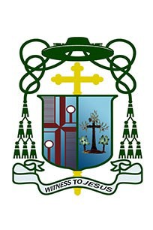
There are many choices a family has in the education and faith formation of their children. We invite all families who have chosen to enroll their children to share in the light of Christ and to cooperate and support the mission and framework of Catholic education in the Diocese of Honolulu.”
Crisis Management Team: (A listing of the C risis M anagement Team responsibilities and contact information follows.)

1. The Pastor shall have the right to make decisions independently or to convene the Crisis Management Team (CMT)

2. The CMT shall be comprised of the Pastor, the Principal of the School, the Director of Religious Education, and faculty members from the schools.

3. A copy of this policy and a roster of CMT members with appropriate telephone numbers shall be available in the offices of the Pastor, the office of the Superintendent of Hawaii Catholic Schools, the office of the Pastor and the offices of the Principal and DRE.

4. The CMT shall act as an advisory group in time of emergency situations.
The Pastor and Education Team will consult in all decisions during emergency situations that includes the closure of buildings, cancellation of classes, suspension of contractual agreements, and the involvement of external emergency personnel such as police.

5. The Pastor is designated as the spokesperson, unless otherwise stated by the Pastor.

6. Individual members of the CMT shall be indemnified by St. Ann Church and School against possible liability incurred in the implementation of their duties.

7. The CMT will analyze the effects, coverage and impact of the crisis within a week of the event.

St. Ann Religious Education and Youth Ministry
Crisis Management Policy

(Updated July 2020)

ACTION PLAN:

Crises are inevitable in the operation of any organization. We make every effort in the St. Ann Religious Education/Youth Ministry program to minimize risk and to assure the safety and security of our students and employees. Since it is not always possible to avoid crisis, planning ahead of time may prevent panic and uncertainties. Under an extreme situation, the Sunday program will follow the St. Ann School Crises Management Policy which is on file in the Religious Education office. St. Ann Religious Education/Youth Ministry programs conduct an evacuation and a lock-
down drill at least two times a year. Other emergency responses are listed below:

Response to emergency situation:

1. Determine the seriousness of the situations.

2. Call 911. If unable to reach 911, call emergency number directly for ambulance, fire or police (see phone listing)

3. Render assistance or call a certified First Aid Person to help you.

4. Contact the Director of Religious Education (DRE). The DRE will determine if the Pastor needs to be contacted. Do not call or involve others without further instructions. If the emergency affects the entire RE/YM program, the DRE will initiate telephone notification of Pastor and all persons deemed appropriate.

5. If a child is involved, a staff member must remain with the child at all times during the emergency. All other children are moved to another area. A teacher is to stay with this group until the all clear signal is given.

6. A staff member must stand at the entrance of the emergency area to direct emergency response personnel.

7. Someone from the RE/YM programs must accompany the child/adult who is to be transported in an ambulance to the nearest medical facility.

8. Parents are advised to listen to local radio/TV stations in the event of
a local crisis.
OUR PARISH

MISSION STATEMENT: The purpose of St. Ann's Parish is to be a Catholic community responsibly committed in word and action to the proclamation and celebration of the Gospel.


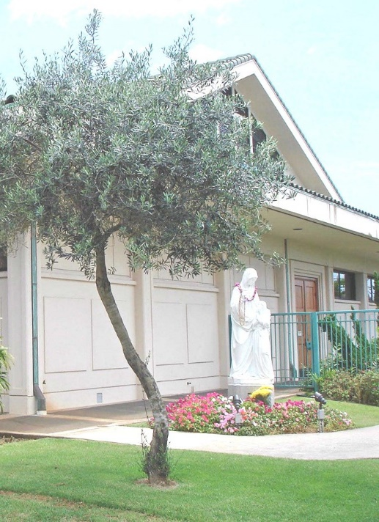
Parish Goals:

1. To grow in our knowledge and under- standing of our faith commitment.

2. To better celebrate our faith life in community.

3. To increase the number of resource people by training members of the faith community in roles of leadership.

4. To deepen our proclamation of the gospel through loving service to our neighbor.

5. To evaluate the implementation of the goals and objectives once each year in the light of the mission statement.
(1983)

PROUD HISTORY: During the persecution of Catholics in Hawaii (circa
1839), many natives had fled from Honolulu over the Pali trail to the windward side and settled in the Koolau area. Father Robert Walsh, SS.CC. (Congregation of the Sacred Hearts of Jesus and Mary, the same community as that of Father Damien of Molokai) began ministering to these Catholics. In 1841, Father Martial Jan, SS.CC. replaced Fr. Walsh and centered the mission in the Heeia area. From the Church's very beginning in 1841, the missionaries established classes for the children in the district. At first, these classes were instructions about the Catholic faith; very quickly they included reading, writing, arithmetic, and a little

OUR CATHOLIC IDENTITY

The St. Ann Religious Education/Youth Ministry program provides a challenging, coherent, and relevant Religion curriculum that fulfills the program’s philosophy and mission by emphasizing that all children can learn and have the right to Religious Education. The first five strands of the Religion curriculum are based on the Catechism of the Catholic Church which are Creed, Liturgy and Sacraments, Morality, Prayer and Scripture. The sixth strand is on the SS.CC. Charism, which functions as the heart of the Parish/Schools’ identity. This is due to the strong historical and relevant presence of the Congregation of the Sacred Hearts of Jesus and Mary for the past 1789years in the parish community.

Service Learning is an integral part of our Religion curriculum. Service Learning is a process that is more than mere isolated acts of volunteerism, but rather an on-going process that services local and global communities. The St. Ann Religious Education/Youth Ministry program identifies a community in need and determines ways in which students can learn, service, and reflect upon that community’s needs. Service Learning Projects are integrated within the religion curriculum according to age appropriateness and time-frame for class on Sundays. The Youth Ministry groups normally complete their service learning projects outside of the regular Sunday program. All service learning projects are linked to one or more themes of Catholic Social Teaching.

The St. Ann Religious Education/Youth Ministry program emphasizes learning and lived experiences that develop an awareness of Catholic attitudes and behavior that can be applied to students’ personal lives. Students are also prepared for the various sacramental programs that are part of their faith formation. Our programs strive to incorporate moral decision-making and critical thinking skills that help students form a community of individuals responsibly committed in word and action to the principles and values of Jesus Christ. Students are taught to be aware of others and that God is present in all of our lives.

OFFICE/CLERICAL
-Monday through Thursday: run-offs, mail-outs, record-keeping.
-Sunday: attendance, registration, phones

CODE OF CHRISTIAN CONDUCT COVERING STUDENTS AND PARENTS/ GUARDIANS:

Parents are the primary educators for their children. The students' interest in receiving a quality, morally based education can be served if students, parents, catechists and administration work together. Differences between these individuals can be resolved. In some instances, however, the Religious Education/Youth Ministry program may find it necessary, in the best interest of the student, to require parents/guardians to withdraw their child.

It is our condition of enrollment that all students behave in a manner, both on and off campus, that is consistent with the Christian principles of the RE/ YM program as determined by the program in its discretion. These principles include, but are not limited to, any policies, principles or procedures set forth in the Student/Parent Religious Education/Youth M inistry Handbook.

These Christian principles further include, but are not limited to, the following:

Parents/Guardians are expected to work courteously and cooperatively with the RE/YM program to assist the student in meeting the academic, moral and behavioral expectations of the RE/YM program.

Students and parents/guardians may respectfully express their concerns about the RE/YM operation and its personnel. However, they may not do so in a manner that is discourteous, scandalous, rumor driven, disruptive, threatening, hostile, or divisive.

The expectations for students and parents/guardians include, but are not limited to, all school-sponsored programs and events (e.g., retreats, prayer services, service opportunities).

The school reserves the right to determine which actions fall short of meeting the Christian principles of the Religious Education/Youth Ministry program. Failure to follow these principles may result in a verbal or written warning to the student and/or parent/guardian and will first result in disciplinary action short of a requirement to withdraw from the school (i.e., suspension of student or suspension of parent/guardian's privilege to come on the campus grounds and/or participate in parish/school activities, volunteer work, etc.) The RE/YM program reserves the right to determine when conduct is of such a severe nature as to warrant immediate action without a warning.

TEACHER/LEADERS: A systematic program of training is offered to all teach- ers and leaders. This includes Teacher In-Service training & workshops, and required diocesan courses.

COMMUNICATION: Information and events are communicated through mail- ings & flyers, a monthly Religious Education Newsletter, the Parish Bulletin, emails, and via the internet at www.saintannhawaii.org

PARENT OUTREACH AND SUPPORT:

Parents can best support their child in Religious Education by:

*attending Mass each week with your children

*getting children to class regularly and on time

*taking an interest in what is happening in the Religious Education classroom

*practicing and living the faith your children are learning

The St. Ann Religious Education/Youth Ministry program encourages parent support and volunteerism for a number of reasons:

1) To develop a positive relationship between the program and the home;

2) To provide assistance with special events, clerical work, and instructional aid;

3) To develop a greater appreciation for the parish as a partnership with parents and catechists;

4) To provide opportunities for contributing skills and talents;

5) To increase communication.

6) To participate as volunteers in all areas of the Religious Education/Youth
Ministry programs.

The following lists areas and related activities in which parents or post Confir- mation students can participate:
SPECIAL EVENTS
-Open Houses -Fundraisers/Scholarship Dinner & Dance
-Assemblies -Holy Days/Holidays
-Christmas Festival -Individual class/group activities

INSTRUCTIONAL AIDE
-Works with catechist to assist in preparing lesson plans, activities
-Assists students with activities
OUR PROGRAMS


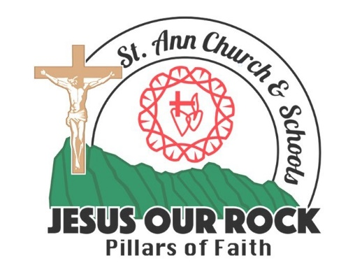
ROLE OF RELIGIOUS EDUCATION: The goal of Catholic education is to
empower children and youth as thinking active Catholics and to develop within them a love for Jesus and his Church.

In the 2017-2018 school year, St. Ann's Education programs embarked upon an exciting challenge envisioned to strengthen
and further our mission: Jesus Our Rock...Pillars of Faith.

The leadership of St. Ann's parish community united all educational programs for greater collaboration, cooperation and communication. By working together and sharing common goals and problems, it is hoped that there will also be a better understanding of our mission, an appreciation of the individual differences and a respect for personal talents. The educational programs of the parish are coordinated by the Education Team. The Education Team consists of:

Pastor
Director of Religious Education
Principal of the School (grades 1-8)
Director of the Early Learning Center (ages 2-5) Education Administrative Assistant

The St. Ann Religious Education Office directs, coordinates, plans, organizes and evaluates all parish religious education programs for youth. The Director of Religious Education also serves as a resource to the School and ELC program.

The St. Ann Religious Education /Youth Ministry program is thriving and vibrant due to the dedication and enthusiasm of our volunteer parishioners. These catechists are responsibly committed to their Catholic Christian faith through the proclamation and celebration of the Gospel in both word and action.



RELIGIOUS EDUCATION

A unified religious education program is conducted for our youth in the Early Learning Center, School, Sunday Elementary program and Youth Ministry. We believe:

1. Each child has the right to Religious Education

2. Each child has the right to use the facilities of the parish.

3. The Parish Religious Education program encompasses all age levels.

4. There are elements in School and Sunday Religious Education which are different and must be addressed in context.

5. Parents are the primary religious educators of their children.

6. A child is considered to be adequately educated by the teacher when he/she has learned the basic content as given according to his/her grade level.

7. Religious Education will help each child to grow in responsibility and commitment in the proclamation and celebration of the Gospel.

8. Parental involvement is vital to the Religious Education of the child.
1983
COMPREHENSIVE YOUTH MINISTRY PROGRAM: Youth Ministry includes middle school youth (grades 6-8) and high school youth (grades 9-12).
Goals of Catholic Youth Ministry:
• Goal 1: To empower young people to live as disciples of Jesus Christ in our world today. (R enewing the Vision, p.9)
• Goal 2: To draw young people to responsible participation in the life, mission, and work of the Catholic faith community. (RTV, p. 11)
• Goal 3: To foster the total personal and spiritual growth of each young person. (RTV, p. 15)
~ Roman Catholic Church in the State of Hawaii - Diocese of Honolulu

St. Ann Comprehensive Youth Ministry - Grades 6 through 8
• YM students in grades 6-8 attend regular Sunday classes during the REYM
academic year.
• Special events are offered to middle school aged students throughout the year (e.g., Middle School Retreat, social activities, service experienc- es, advocacy events). Please note that events that take place outside of the regular Sunday class hours will require a signed permission form.

St. Ann Comprehensive Youth Ministry - High School
• Students in High School attend a bi-weekly Youth Night gathering on cam-
pus for ongoing formation in faith and community building. These gather- ings follow the Sunday 5pm Mass, from 6pm to 7:30pm on the following dates:
September 13 & 27 February 7 & 21
October 11 & 25 March 14 & 28
November 8 & 22 April 11 & 25
December 13 May 2
January 10 & 24
High School students are encouraged to attend 5pm Mass on these
Sundays and meet directly following Mass for the Youth Night.
• Special events are offered to High School aged students throughout the year (e.g., C2BC Retreat, social activities, service experiences, advocacy events). Please note that events that take place outside of the regular Youth Night hours and/or take place off campus will require a signed permis- sion form.

SACRAMENT PROGRAMS: Students wishing to receive the sacraments
for the first time are required to register with the Religious Education Office at the beginning of the school year. Baptism/Birth Certificate is required. All verifying documents must be submitted no later than October 6 2019. Students must attend a minimum amount of classes as determined for designated level.

♦ 1st RECONCILIATION, CONFIRMATION & 1st EUCHARIST: Formal catechesis begins in the 1st grade and continues through the end of the
2nd grade year:

• Sacramental Prep - Level I (Formerly called Grade 1)

• Sacramental Prep - Level II (Formerly called Grade 2)

Note: Students entering the RE program in the 2nd grade with no previous formal catechesis will be enrolled in Sacramental Prep Level I. Students entering the RE program in the 3rd thru 6th grades with no previous formal catechesis will be enrolled in RCIC I.

♦ RCIC I: For children between the ages of 7 to 16 years who wish to receive the Sacraments of Initiation (Baptism, Confirmation, Eucharist). This is the first year of a two year process.

♦ RCIC II: For children between the ages of 7 and 16 years who have completed RCIC I (or are already baptized and have had prior catechesis) who wish to receive the sacraments of Reconciliation, Confirmation and First Eucharist.

♦ CONFIRMATION : There is a two year preparation period for
Confirmation (for children and teens from Grade 3 thru High School).

Note: For High School students also seeking Baptism and/or 1st Reconciliation & Eucharist, enrollment in an additional Sacrament Preparation class is required.

Sessions are required for parents of children preparing to receive
sacraments. Failure to attend parent classes may lead to the postponement
of the sacrament. Sessions are announced through the monthly Religious
Education Newsletter, emails or by special flyers.

Parents are also encouraged to update themselves and to increase their understanding of the Church by participating in various programs offered at St. Ann’s (i.e., Scripture Study Classes, Seasonal Workshops & Retreats, RCIA Program). For further information regarding sacrament programs, please contact the Religious Education Office at 247-3092, extension 104.
REGISTRATION AND FEES: To register, parents or legal guardians complete a registration form at the start of each academic year and return it to the Religious Education office. On-line registration is also available. A non-refundable fee covers textbooks, classroom supplies and designated activities. Additional costs are incurred in the Youth Ministry program. Registration fees must be paid before students will be enrolled in the program. If cost is a factor, please contact RE Office. Students who show up for class and whose names are not on the class list must report to the Religious Education Office. *N ote: Parish registration and child’s Birth Certificate are required for families

participating in RE/YM Program. Baptismal Certificate is also required for those students already baptized.

SESSION TIMES: All Sunday Elementary
(Gr. Pre-K - 5) and Youth Ministry (Gr. 6 -
8) sessions begin at 10am and end at
11:15am (Refer to page 13 for High School Youth Ministry times and dates). Preschool and Kindergarten children must be signed in and out by a parent or designated guardian. They must also be toilet-trained.

EARLY RELEASE: If a child is to be released early, a request must be made in writing or by phone before 10am to the RE Office. A parent/guardian must sign a Release Form in the RE Office before taking student off campus. Students will be released to parent/guardian from the RE Office.

ABSENCES: Please call the Religious Education office in the event of an absence. After two (2) consecutive absences the Religious Education office contacts the parents. After six (6) consecutive absences, a deactivation notice is sent home to the parent(s). Attendance is vital to the effective faith formation of students in the RE/YM program. Students and parents should make every effort to attend the catechetical sessions and/or parent meetings offered at the parish.

VISITOR POLICY: All visitors are to check-in at the RE Office before proceeding to classrooms. When leaving campus, visitors and parents check out at the RE Office. Visits to classrooms during session hours must be prearranged and approved by the RE Principal. In addition, visitors who are minors must also be accompanied by a parent/guardian.

BEHAVIOR/DISCIPLINE: The Religious Education/Youth Ministry program shares the classrooms with the School. There is a bulletin board reserved for the RE/YM students to display their work. It is expected that our
students behave in a Christian manner: that each child respect the property of others; that each child participates and cooperates in class activities.
The St. Ann RE/YM program does not allow bullying and intimidation of any kind. Every student has a right to be safe on campus. In today’s world, it is also imperative that the ethical use of technology (social networking, texting, etc.) be addressed. Defacement, misuse of photos and name- calling are not appropriate or acceptable. In the event of continuous disruptive behavior:

1) the teacher talks to the student and/or parents;

2) if behavior continues the Religious Education Office is notified by the teacher and in turn handles the matter;

3) in cases of severe behavior problems a child may be asked to leave the program.

CONCERNING CHILD ABUSE (Safe Environment Program): The “Policy on Allegations and Incidents of Sexual Misconduct” promulgated by the Diocese of Honolulu is incorporated in this handbook by this reference. A copy of the policy is contained in the handbook, “Reconciliation,
Protection, Accountability, 3rd Edition (July 2020)”, first published as “To Offer Healing, To Restore Trust”, January 8, 2004. The handbook is available from the RE Office and may also be accessed at the diocesan website: catholichawaii.org

The Church endorses the mandatory reporting provisions of H.R.S. Chapter
350 concerning child abuse. All Staff Members and Teachers/Catechists are required to sign an acknowledgement that they have read and understood the ethical and personal conduct policies of the Diocese of Honolulu.

Consistent with diocesan policy, St. Ann’s Religious Education/Youth Ministry program will conduct Safe Environment training as part of the religious education curriculum. Parents may request to review the Safe Environment materials by calling the RE Office. Parents who do not wish to have their child participate in this program must provide a written request stating such by September 27, 2020.

LOCK-DOWN/EVACUATION DRILLS: An evacuation plan is posted on the Religious Education bulletin board in each class. In an evacuation, students proceed quickly and quietly to their designated area. Teachers remain with their students until they are given the all clear signal. A Lock-Down / Evacuation drill shall occur at least twice during the RE/YM year.
EMERGENCY PROCEDURES: In case of an emergency in the class, the teacher aide reports the problem immediately to the Religious Education Office. The teacher remains in the class. The Religious Education Office notifies the parents or emergency contact designated on the registration form. If no one can be reached the Office calls 911 for assistance. (Please refer to the St. Ann School Crisis Management Policy on pages 16-18)

STUDENT ACTIVITIES: All student activities scheduled outside St. Ann~s premises are announced by special flyer/mail/email and require a signed
permission form for all grade levels. YM activities sponsored by St. Ann’s are held both on and off campus and will be announced as noted above. These activities, and all YM activities that take place outside of the normal program hours, require a signed permission form. All privately organized outside activities not sponsored by St. Ann’s are not under the leadership, responsibility or liability of St. Ann Church.

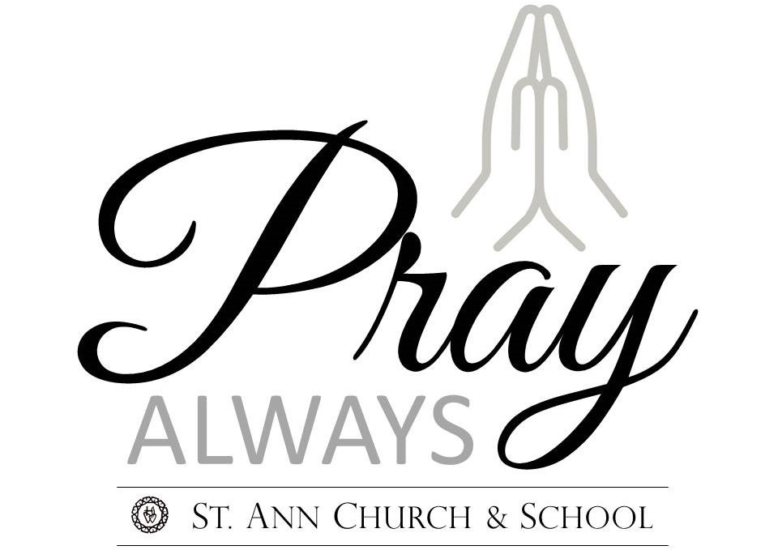
USE OF PICTURES: St. Ann Church & School reserves the right to use student pictures in publications and on the church website. The Religious Education Office must have on file a written notice from any parent prohibiting the use of their child’s picture in RE/YM publications and website. Such notice must be received by September 27, 2020.

